WorkKeys Information for Paraprofessional Licensure

To obtain a Paraprofessional license, you need to meet one of three requirements: an Associate’s Degree, 60 hours of college credit or qualifying scores of 4 on each of the WorkKeys Applied Math and WorkKeys Workplace Documents tests.

The WorkKeys tests are given at the Waterloo Regional Office of Education, 107 East Mill Street, Waterloo, IL 62298 every Tuesday. They are given at the Chester Regional Office of Education, Randolph County Courthouse, 1 Taylor Street, Room 101, Chester, IL 62233 on the first and third Wednesdays of the month. You can call the Waterloo office at 618-939-5650 or the Chester office at 618-826-5471 with questions.

You register for the WorkKeys tests at www.roe45.net/registration. The registration is $20 fee for each test—totaling $40 for first-time testers. Everything you need for testing is provided at the test site. The only thing you will need is a photo ID. Masks are required to enter both testing locations.

Morning testing begins promptly at 9:00 a.m. The ROE asks that you arrive by 8:45 a.m. to sign in and get ready for testing. You will have 55 minutes for each test. You can take an optional 5–10-minute break between tests. You can expect to be finished shortly after 11:00 a.m.

The Illinois State Board of Education has set the required score as 4 for both the Applied Math and the Workplace Documents tests. You will receive your scores immediately after you finishing testing. If you do not meet the required scores, you can retest at your chosen test site on a later date. Retesting is done in the afternoon beginning promptly at 1:30 p.m. You need to retest only the test(s) for which you did not meet the required score. Registration for retesting is done at www.roe45.net/registration. Be at your location by 1:15 p.m. to be prepared to take the retest.

FREE practice tests are available for the WorkKeys tests. Follow the directions below.
Go to http://workkeys.com … make sure WorkKeys Assessment is selected …
Scroll down the page … to the section labeled Preparation …
Select … More Preparation Options …
In the Preparation section … you will find Sample Questions for the three new WorkKeys assessments
- Applied Math … http://www.act.org/content/act/en/products-and-services/workkeys-for-employers/assessments/preparation/applied-mathematics.html?page=0&chapter=4
- Workplace Documents … http://www.act.org/content/act/en/products-and-services/workkeys-for-employers/assessments/preparation/reading-for-information.html?page=0&chapter=0

You will also find Online Practice Tests … select Purchase a Practice Test … Note: If you select a 1.0 Practice Test, you will need a credit card because there is a charge for these prep tests. If you select a 2.0 Practice Test (Applied Math, Workplace Documents, Graphic Literacy) you will not be charged to do the online practice test.
When you select Purchase a Practice Test, you will see a pop-up that indicates “This action will open a new window. Do you want to proceed?” … Select OK.
Your action will open a Validus WorkKeys Window … If you have an account, provide your username/password and log in. If you do not have an account, select Create Account, complete and submit the Create an Account form.
An ACT Practice window will open that will allow you to order and complete practice testing.
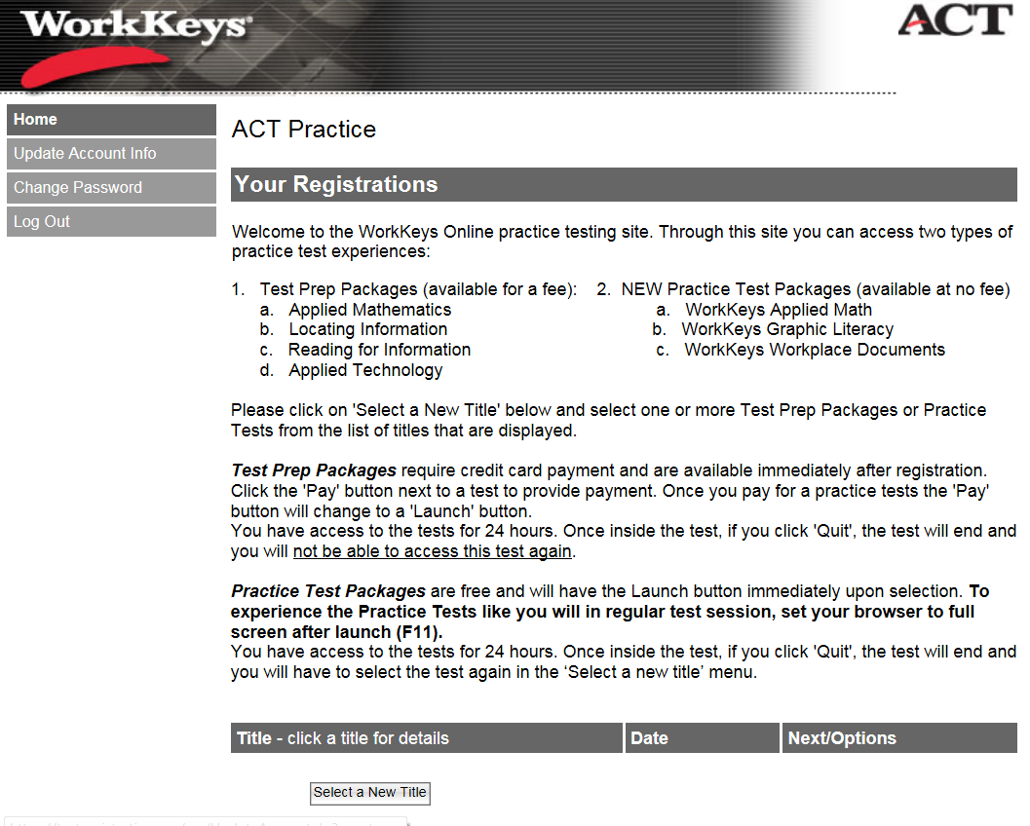
Again, you will see that you will be charged for 1.0 WorkKeys Practice Tests (1) … but not charged for 2.0 WorkKeys Practice Tests (2).
At the bottom of the page … select “Select a New Title” … and select one of the 2.0 WorkKeys Practice Tests …
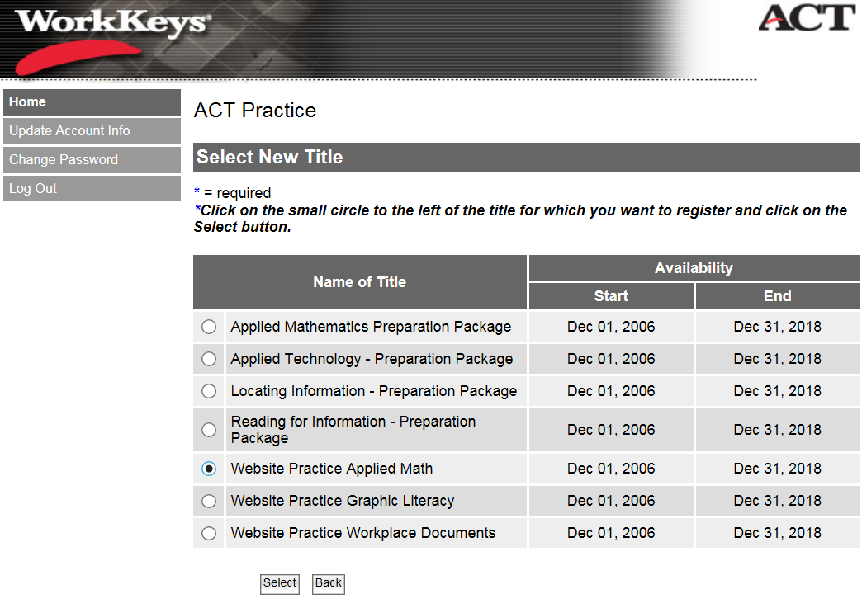
and click the Select button at the bottom of the page.
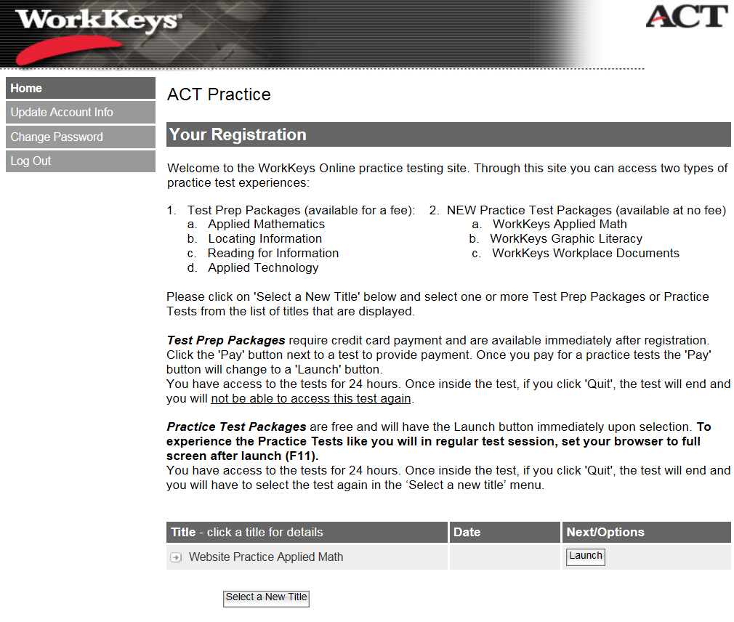
You can launch and take the Practice Test … or you can log back in later and will be able to order and/or launch additional Practice Tests.

